**Summary:**

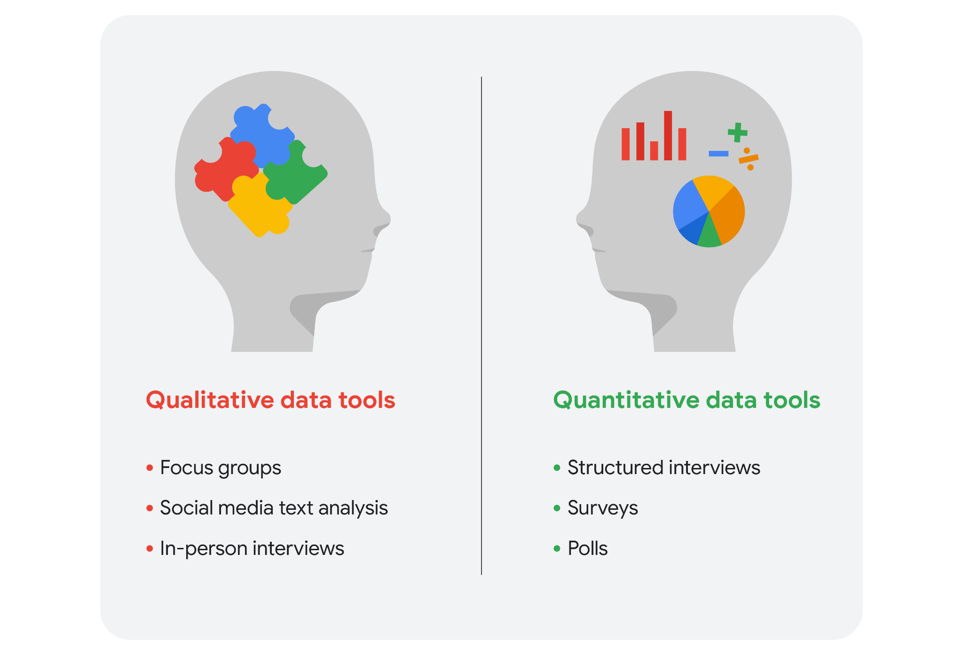

**Learning Log:**

| **Date:** 30-12-22 | **Course/topic:** Course 2: Ask Questions to Make Data-Driven Decisions | | |
| --- | --- | --- | --- |
| **Learning Log:** Ask SMART questions about real life data sources | | |
| **Review your notes** | Before you begin your new entry, take a moment to locate and read the notes you took during your data conversation. Based on the answers to your well-prepared SMART questions, you should have a better context for your target audience now. Review those answers and start thinking about the following:   * Stakeholder’s business goals; in this case, the person you had a conversation with * Identifying the data needed to answer the SMART questions * Exploring what data the stakeholder already has * Determining the data that you don’t have, but need in order to answer the questions | | |
| **Reflection:** | Write 5-7 sentences (100-140 words) for each of the prompts below: | | |
| **Questions and responses:** | First, consider your data conversation and how it went. Write 5-7 sentences (100-140) words about your experience with your data conversation and using SMART questions. Here are some questions to help you get started:   * Was there anything challenging about getting the conversation started? * Were there questions you didn’t get to ask? * Did you manage your time effectively? * Did you take notes? Are they as detailed as you need them to be? * Are you missing any information? Is there anything that you still find unclear or vague? * If you could do the conversation over again, is there anything you would change?   *Type your response here*  Next, turn your attention to your notes and reflect on what you know about the data itself. Write 5-7 sentences (100-140 words) about the data sources that are potentially available for this project. Here are some questions to help you get started:   * What are the sources of data available for the project? * Which data sources were qualitative and which were quantitative? Explain your answer. * What decisions could you make when considering each data source separately? Could you make different decisions about the data if you combined it? If so, give an example. * Is there any kind of data that isn’t available, but you would like to find? If so, what is it, and why would you like to know more about it?   *Response:*   * *We’ve already been in conversations regarding data, AI and other technology so it wasn’t difficult at all.* * *For gauging which career is best there is already lots of data present on the internet.* * *I spent extra time trying to come up with the SMART method of questions since it was just introduced to me!* * *Most of the data available on the internet is qualitative, it’s reviews from people already pursuing a career in the field or someone learning. However there is also quantitative data which helps us estimate earnings, work hours, etc.* * *If we were to consider the data sources separately then the results would come out to be different and conflicting. It depends on which type of qualitative data we get first we might form an opinion around the job roles.* * *Data regarding direct success or failure of pursuing candidates is not available, as it depends upon various factor and not only the term pursuing.* | | |